

**IOT HOME AUTOMATION**

**REPORT OF MINOR PROJECT SUBMITTED FOR PARTIAL FULFILLMENT OF THE REQUIREMENT FOR THE DEGREE OF MASTER OF COMPUTER APPLICATION**

**NAME:-**SANJAY GHOSH **UNIVERSITY ROLL NO:-**11701016010

**REG.NO:-** 161170510015 OF 2016-2017

**UNDER THE SUPERVISION OF**

**MRS. SATABDWI SARKAR**

**Asst . Professor**

**DEPT. OF COMPUTER APPLICATION**

**RCC INSTITUTE OF INFORMATION TECHNOLOGY**

**AFFILIATED TO MAULANA ABUL KALAM AZAD UNIVERSITY OF TECHNOLOGY**

**CANAL SOUTH ROAD, BELIAGHATA,KOLKATA-700015**

**RCC INSTITUTE OF INFORMATION TECHNOLOGY**

**KOLKATA-700015, INDIA**



**CERTIFICATE**

The report of the project titled “**IOT HOME AUTOMATION”** submitted by Sanjay Ghosh (Roll no:- 11701016009 ), Madhurima Neogy ( Roll no:- 11701016019),Shagufta Khanam (Roll no:- 11701016009) of MCA 5th  semester 2018 has been prepare under my/our supervision for the partial fulfillment of the requirements for MCA degree in Maulana Abul Kalam Azad University Technology. The report is hereby forwarded.

----------------------------------

[Internal Supervisor]

[Dept of Computer Application]

[RCCIIT,Kolkata]

-------------------------------

[ Head Of the Department ]

Dept. Of Computer Application

RCC Institute of Information Technology, Kolkata

**ACKNOWLEDGEMENT**

We would like to express our sincere gratitude to **Asst. Mrs. Satabdwi Sarkar**, Department of Computer Application, RCC Institute of Information Technology and whose role as project guide was invaluable for the project. We are extremely thankful for the keen interest she took in advising us, for the books and reference materials provided for the moral support extended to us.

I am also indebted to our Head of the Department (MCA), **Mr. Arup Kumar Bhattachrya** for his unconditional help and inspiration.

Signature of the student with date:

1. Sanjay Ghosh ………………………………………

**RCC INSTITUTE OF INFORMATION TECHNOLOGY**

**Kolkata-700015, INDIA**



**CERTIFICATE OF ACCEPTANCE**

The report of the project titled **IOT Home Aotomation** submitted by Shagufta Khanam (Roll No: 11701016009), Madhurima Neogy (Roll No: 11701016019), Sanjay Ghosh (Roll No: 11701016010) of MCA 5th Semester of 2018-2019, is hereby recommended to be accepted for the partial fulfillment of the requirements for MCA degree in Maulana Abul Kalam Azad University of Technology.

**Name of the examiner(s) Signature with date**

1. .................................................

2. .................................................

**index**

**TOPICS PAGE NO**

1. Introduction.............................................................................. 1

2. Objective.................................................................................. 2

3. Feasibility Study........................................................................ 3

4. Software Requirement Specification.......................................... 4

5. Hardware and Software Requirement....................................... 5

6. Design...................................................................................... 6

7. Screenshots............................................................................. 8

8. Sample Coding......................................................................... 12

9. Future scope of project……………………………………………………… 19

10. Conclusion............................................................................ 20

11. Reference............................................................................ 21

**INTRODUCTION**

In the present day, security systems play an important role in the protection of lives and

investment. This is achieved by the incorporation of various subsystems into the security system with a single control unit such as, motion control, access control, fire detection, etc. A smart home is one that is equipped with lighting, heating, and electronic devices that can be controlled remotely by smartphone or via the internet. Home automation gives an individual the ability to remotely or automatically control things around the home. A home appliance is a device or instrument designed to perform a specific function, especially an electrical device, such as a bulb, fans, and door for household use. The appliances which are handled by automation, lowers the human judgment to the lowest degree possible but does not completely eliminate it. The concept of remote management of household devices over the internet from anywhere, any time in the world.

The recent developments in the technology which permit the use of Bluetooth and Wi-Fi have enabled different devices to have capabilities of connecting with each other. Using a WIFI shield to act as a Micro web server for the Arduino eliminates the need for wired connections between the Arduino board and computer which reduces cost and enables it to work as a standalone device.

A web portal is designed with a one-factor authentication system (username and password) to check authenticity of the home user. It acts as an input device to control the home appliances and also acts as an output device.

**OBJECTIVE**

The designed home automation system can work as an intelligence system as it will sense the motion of human body and will react according to that.We have implemented the concept of Internet of things. The main goal of this system is to provide as much comfort as possible to a common household without much of training and difficulty. All the household things would just be one touch or voice away. And will be operated from anywhere in the world as it will be operated through internet and our handphone.

To facilitate the wireless connectivity with the system, the Arduino Uno will be embedded with a WiFi module. This establishes the internet connection to the system and all the home appliances can in turn be connected and controlled by internet.

We are using an app like interface where we can provide the command through the mobile phone rather than by the voices. This would be beneficial in some ways. This system will keep a back up or the option to be controlled by the voice or phone as per our requirement.

The integrated sensors such as the temperature sensor read temperature values, the gas sensor detects smoke and cooking gas to avoid fire outbreak. The automatic switching on and off of the light is controlled by the Light Dependent Resistor (LDR) which determines the day light intensity. Also to incorporate security in our design, a motion detector is integrated to detect movement in the home when the security system is turned on. A relay switch is used to send control signals from the micro-controller to the electronic device used to achieve the switching on and off action.

**FEASIBILITY STUDY**

This section aims to judge the cost requirement and value to be obtained. The types of feasibilities we used are:

Technical feasibility: Before the project started we thought of the technologies we would be using. So we used many kinds of sensors and a power generator and microcontroller to depict the vision we wanted to show.we used breadboard and wires with some sensors and smps to show the physical presentation and used Arduino to perform the programming part which would connect the hardware devices and the funtionalitues among them. We connected our project to Adafruit which provided us a platform to control the devices through a phone.

Resourse feasibility: We decided to check the resoursed wo would need to perform the task took help from the internet to get the information related to that. We needed concept of programming and a good knowledge of microcontroller. We also needed some computers where we can done the programming part and quite a number of hardware parts. We needed to prepare a backup as it is a hardware related work it might explode or any interruption can happen.

Schedule feasibility: We almost completed our project within 3-4 months which we were given. And got enough time to check if everything is working good or not. But the final outcome what we want might take some more time.

**Software Requirement Specification**

Requirement specification is done in order to understand how the system is expected to perform. For system like Home Automation that has to handle both dash board panel and voice recognition. The system should provide proper security during the login process to access.

**Initial Step-By-Step Description-**

**(From user view)**

1. Login in Adafruit and directly go to the dash board.
2. Control the panel of dash board as per your choice.
3. It has one more way to access the home equipment by giving voice command using Google Assistant.
4. When the commands are sent to the system it sends them to the server IFTT

In case of Google assistant and MQTT in case of Dashboard.

1. Then According to the conditions it performs the tasks which device to turn off or on.

The only important thing to keep in mind is to keep the user-id and password secret and should always be connected to the Internet so that we can access all the things from any distance.

**HARDWARE AND SOFTWARE REQUIREMENT**

Front-end:- Adafruit IO and Google Assistant

Back-end:- MQTT and IFTT

Operating System:- 64 bit windows and screen area of 1366*786 pixels

Software used:- Google Assistant ,Adafruit, Arduino

**Hardware Components:**

* Node MCU
* Gas Sensor (MQ 135)
* PIR Motion
* LDR Module
* Relay Board
* Fan
* Bulb
* Wire
* Bread Board

**Requirement to run (Recommended):**

* Windows 7
* 512 MB RAM
* 30 GB Hard disk
* Processor intel i3

1.When system is in OFF state.

Screenshots

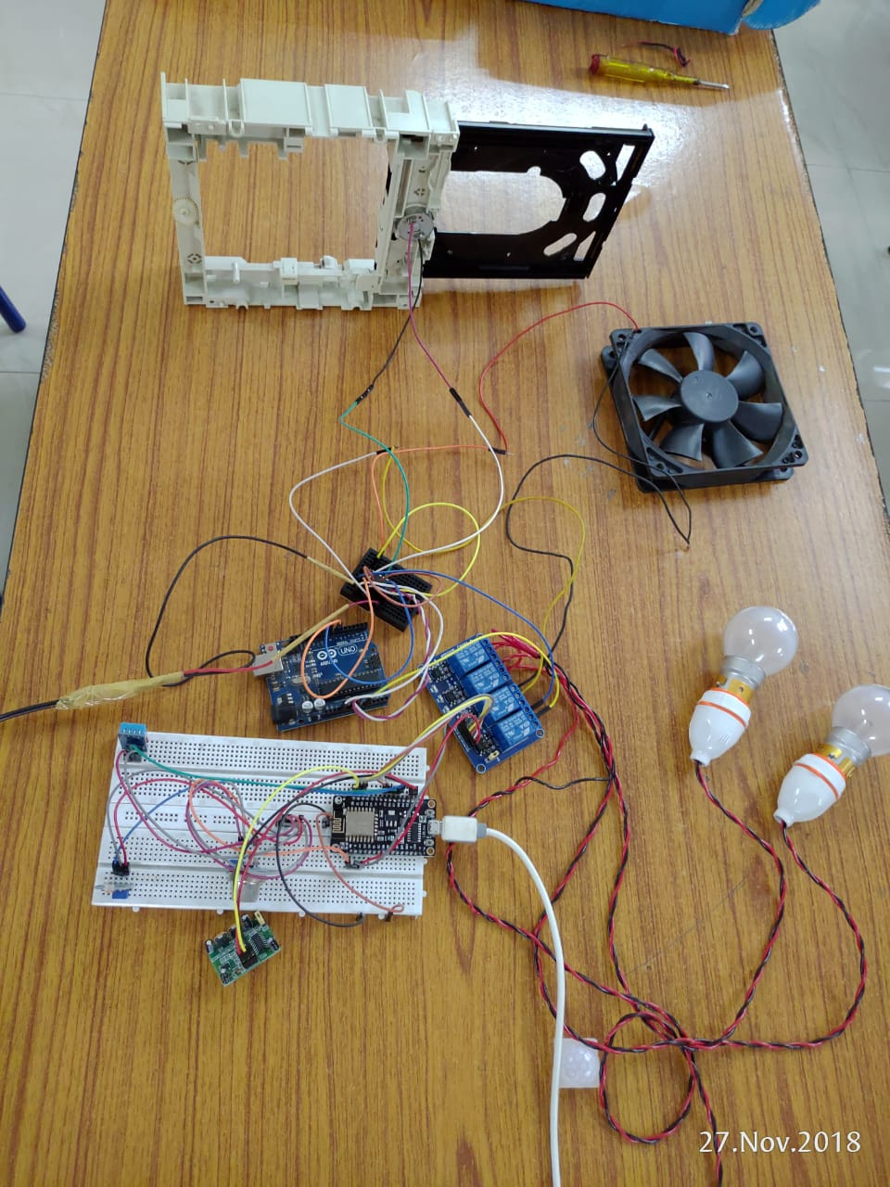

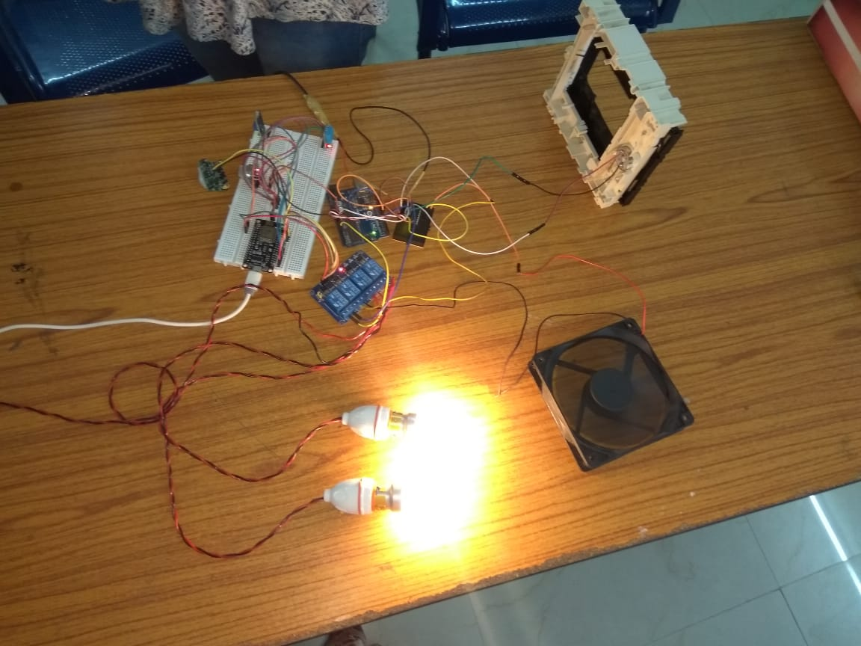

3.When system is ON state but Door is Open

4.When System is ON and DOOr is CLOSED.

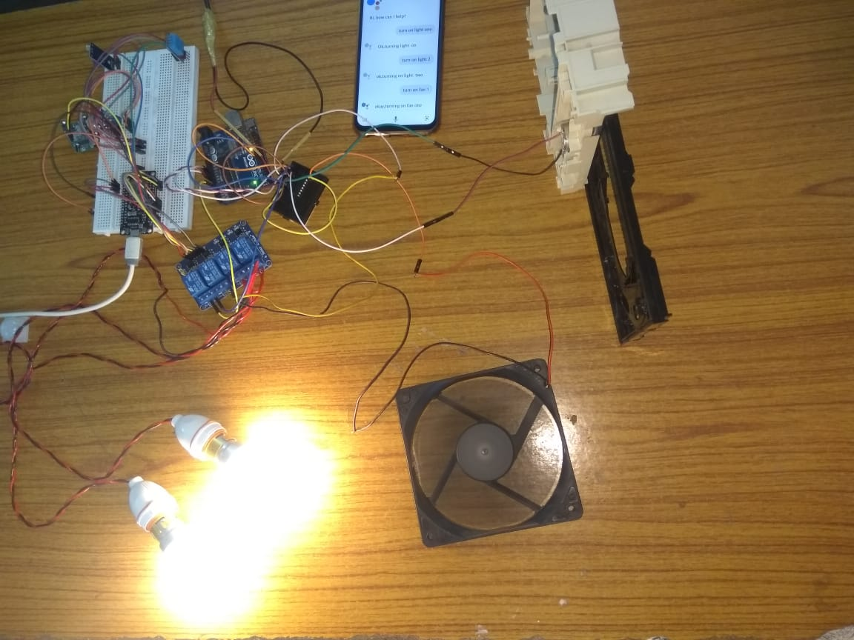

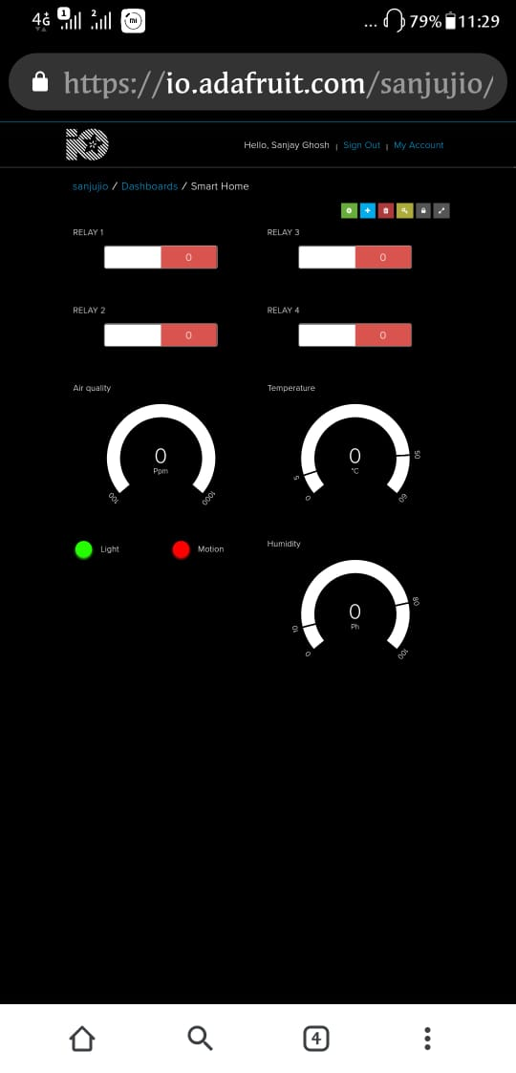

5.Dashboard

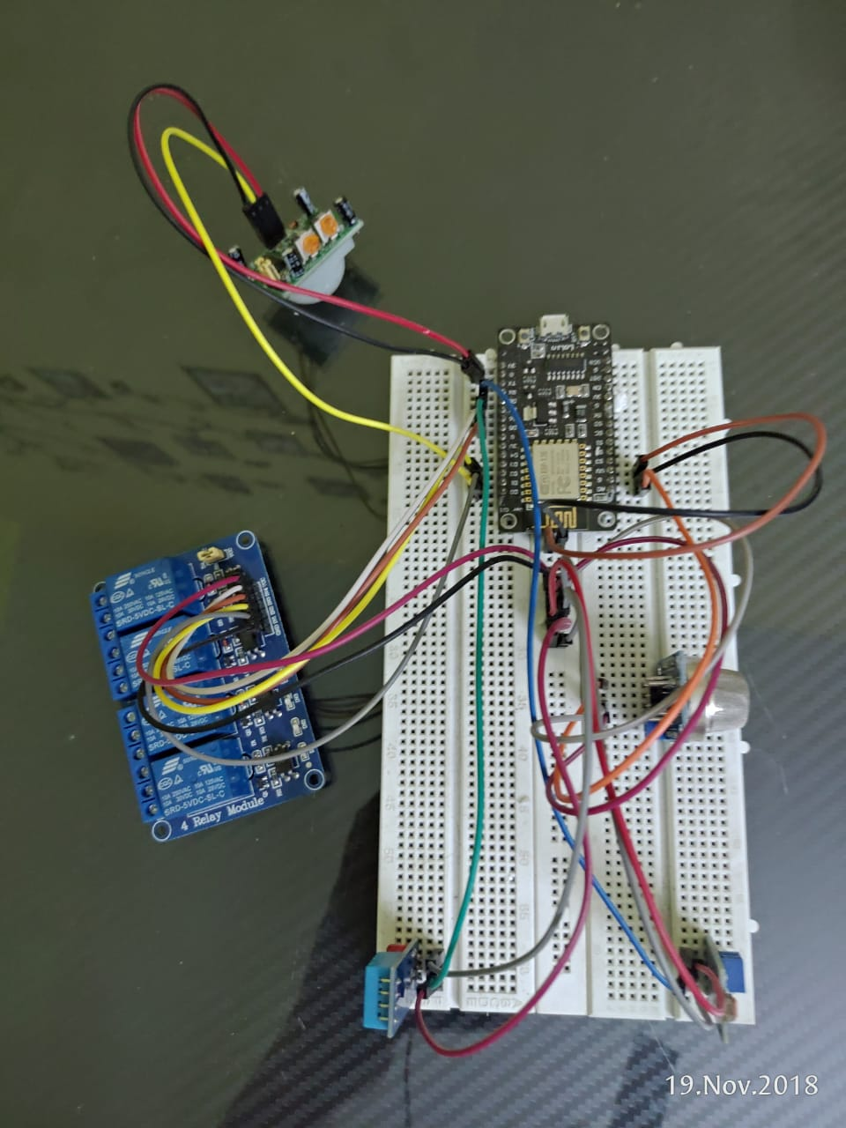

6.Breadboard Connection with sensors

design

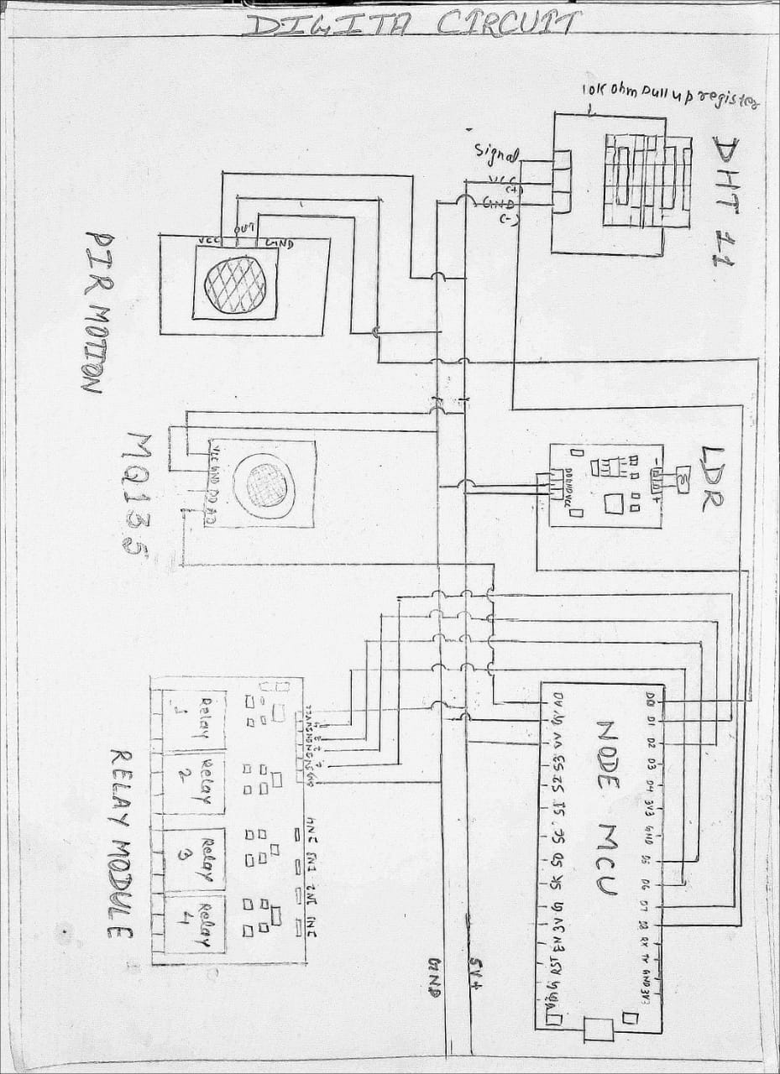

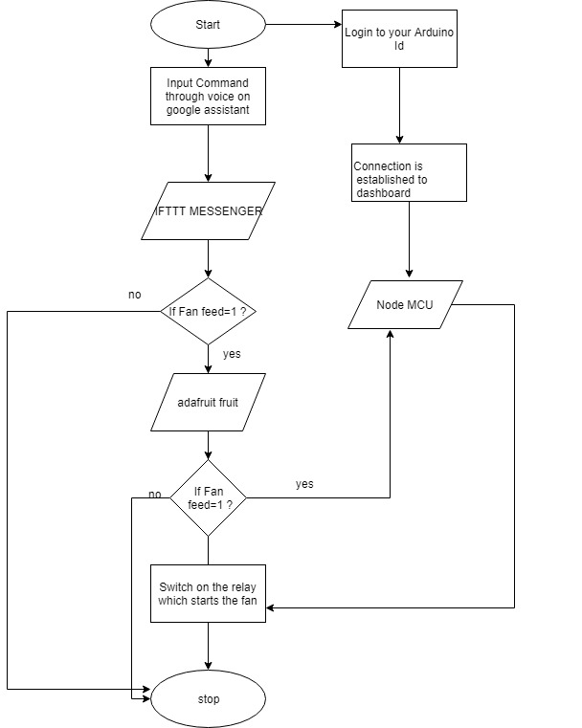

Flow Chart

Sample code

#include <ESP8266WiFi.h>

#include "Adafruit_MQTT.h"

#include "Adafruit_MQTT_Client.h"

#include "DHT.h"

/************************* Pin Definition *********************************/

//Relays for switching appliances

#define Relay1 D1

#define Relay2 D2

#define Relay3 D5

#define Relay4 D6

//DHT11 for reading temperature and humidity value

#define DHTPIN D7

//LDR for light detection

#define ldrpin D8

//PIR for motion detection

#define pirpin D0

//Analog pin to read the incoming analog value from different sensors.

#define analogpin A0

/************************* WiFi Access Point *********************************/

#define WLAN_SSID "Sanju-phn"

#define WLAN_PASS "12344321"

/************************* Adafruit.io Setup *********************************/

#define AIO_SERVER "io.adafruit.com"

#define AIO_SERVERPORT 1883

#define AIO_USERNAME "sanjujio"//"techiesms"

#define AIO_KEY "a9cbee6441934bbcb1ba971480eb6096"

/*****************************************************************************/

// Create an ESP8266 WiFiClient class to connect to the MQTT server.

WiFiClient client;

// Setup the MQTT client class by passing in the WiFi client and MQTT server and login details.

Adafruit_MQTT_Client mqtt(&client, AIO_SERVER, AIO_SERVERPORT, AIO_USERNAME, AIO_KEY);

/****************************** Feeds ***************************************/

//Feed for sensors

Adafruit_MQTT_Publish Humidity = Adafruit_MQTT_Publish(&mqtt, AIO_USERNAME "/feeds/humidity");

Adafruit_MQTT_Publish Temperature = Adafruit_MQTT_Publish(&mqtt, AIO_USERNAME "/feeds/temperature");

Adafruit_MQTT_Publish CO2 = Adafruit_MQTT_Publish(&mqtt, AIO_USERNAME "/feeds/co2");

//Adafruit_MQTT_Publish Sound = Adafruit_MQTT_Publish(&mqtt, AIO_USERNAME "/feeds/sound");

Adafruit_MQTT_Publish Motion = Adafruit_MQTT_Publish(&mqtt, AIO_USERNAME "/feeds/motion");

Adafruit_MQTT_Publish Light = Adafruit_MQTT_Publish(&mqtt, AIO_USERNAME "/feeds/light");

//Feed for relays

Adafruit_MQTT_Subscribe Light1 = Adafruit_MQTT_Subscribe(&mqtt, AIO_USERNAME "/feeds/relay1");

Adafruit_MQTT_Subscribe Light2 = Adafruit_MQTT_Subscribe(&mqtt, AIO_USERNAME "/feeds/relay2");

Adafruit_MQTT_Subscribe Fan1 = Adafruit_MQTT_Subscribe(&mqtt, AIO_USERNAME "/feeds/relay3");

Adafruit_MQTT_Subscribe Fan2 = Adafruit_MQTT_Subscribe(&mqtt, AIO_USERNAME "/feeds/relay4");

/*********************** Declaration for DHT11 *****************************/

#define DHTTYPE DHT11 // DHT 11

DHT dht(DHTPIN, DHTTYPE);

uint32_t delayMS;

/*************************** Sketch Code ************************************/

void MQTT_connect();

void setup() {

Serial.begin(115200);

delay(10);

pinMode(Relay1, OUTPUT);

pinMode(Relay2, OUTPUT);

pinMode(Relay3, OUTPUT);

pinMode(Relay4, OUTPUT);

pinMode(analogpin, INPUT);

pinMode(ldrpin, INPUT);

pinMode(pirpin, INPUT);

Serial.println(F("Adafruit MQTT demo"));

// Connect to WiFi access point.

Serial.println(); Serial.println();

Serial.print("Connecting to ");

Serial.println(WLAN_SSID);

WiFi.begin(WLAN_SSID, WLAN_PASS);

while (WiFi.status() != WL_CONNECTED) {

delay(500);

Serial.print(".");

}

Serial.println();

Serial.println("WiFi connected");

Serial.println("IP address: "); Serial.println(WiFi.localIP());

//Setting up DHT sensor

dht.begin();

// Setup MQTT subscription for onoff feed.

mqtt.subscribe(&Light1);

mqtt.subscribe(&Fan1);

mqtt.subscribe(&Light2);

mqtt.subscribe(&Fan2);

}

uint32_t x = 0;

void loop() {

MQTT_connect();

Adafruit_MQTT_Subscribe *subscription;

while ((subscription = mqtt.readSubscription(20000))) {

if (subscription == &Light1) {

Serial.print(F("GotL1: "));

Serial.println((char *)Light1.lastread);

int Light1_State = atoi((char *)Light1.lastread);

digitalWrite(Relay1, Light1_State);

}

if (subscription == &Light2) {

Serial.print(F("GotL2: "));

Serial.println((char *)Light2.lastread);

int Light2_State = atoi((char *)Light2.lastread);

digitalWrite(Relay2, Light2_State);

}

if (subscription == &Fan1) {

Serial.print(F("GotF1: "));

Serial.println((char *)Fan1.lastread);

int Fan1_State = atoi((char *)Fan1.lastread);

digitalWrite(Relay3, Fan1_State);

}

if (subscription == &Fan2) {

Serial.print(F("GotF2: "));

Serial.println((char *)Fan2.lastread);

int Fan2_State = atoi((char *)Fan2.lastread);

digitalWrite(Relay4, Fan2_State);

}

}

// For publish stuff!

Serial.print("Motion "); Serial.println(digitalRead(pirpin));

Serial.print("...");

float m = digitalRead(pirpin);

if (! Motion.publish(m)) {

Serial.println(F("Failed"));

} else {

Serial.println(F("OK!"));

}

Serial.print("C02 "); Serial.println(analogRead(analogpin));

Serial.print("...");

float c = analogRead(analogpin);

if (! CO2.publish(c)) {

Serial.println(F("Failed"));

} else {

Serial.println(F("OK!"));

}

Serial.print("Light "); Serial.println(digitalRead(ldrpin));

Serial.print("...");

float l = digitalRead(ldrpin);

if (! Light.publish(l)) {

Serial.println(F("Failed"));

} else {

Serial.println(F("OK!"));

}

// Reading temperature or humidity takes about 250 milliseconds!

// Sensor readings may also be up to 2 seconds 'old' (its a very slow sensor)

float h = dht.readHumidity();

// Read temperature as Celsius (the default)

float t = dht.readTemperature();

// Read temperature as Fahrenheit (isFahrenheit = true)

float f = dht.readTemperature(true);

// Check if any reads failed and exit early (to try again).

if (isnan(h) || isnan(t) || isnan(f)) {

Serial.println("Failed to read from DHT sensor!");

return;

}

Serial.print("Humi "); Serial.println(h);

Serial.print("...");

if (! Humidity.publish(h)) {

Serial.println(F("Failed"));

} else {

Serial.println(F("OK!"));

}

Serial.print("Temp "); Serial.println(t);

Serial.print("...");

if (! Temperature.publish(t)) {

Serial.println(F("Failed"));

} else {

Serial.println(F("OK!"));

}

}

void MQTT_connect() {

int8_t ret;

// Stop if already connected.

if (mqtt.connected()) {

return;

}

Serial.print("Connecting to MQTT... ");

uint8_t retries = 3;

delay(200);

while ((ret = mqtt.connect()) != 0) { // connect will return 0 for connected

Serial.println(mqtt.connectErrorString(ret));

Serial.println("Retrying MQTT connection in 5 seconds...");

mqtt.disconnect();

delay(5000); // wait 5 seconds

retries--;

if (retries == 0) {

// basically die and wait for WDT to reset me

while (1);

}

}

Serial.println("MQTT Connected!");

delay(2000);

}

projectcode

Displaying projectcode.

**Future scope of Home automation**

The Home automation we made would be able to turn any ordinary home into smart home rather than buying or replacing our old electronic appliances. We can make a system which would be combined with the circuit we designed and that can be just place with the main circuit of anybody’s home and will make the other devices work as smart devices. The only requirement of that kind of system would be internet connection, whether it is from a Wi-Fi router or from mobile hotspot.

Other than this we can also extend it to control all the appliances with our voice and app existing at our home. Whether it is a small appliance or a heavy. Even though smart home is available these days but that needs smart system to operate on and minimal knowledge of smart system but we can provide an easy learning and implementing system which will be at reasonable price so that everybody can use.

CONCLUSION

Our project Home Automation works with the Voice control and app to control all the home appliances .It provides a feature to have a user-Id and password so that the authentic users can only login and operate the system from anywhere in the world and also it would need just an internet connection to work with.

We can operate our regular home appliances as well as measure temperature, heat and detect the motion of a body within the radius of 5 meter from our home. We would not need to buy extra ‘Smart’ Home appliances to make our home ‘Smart’. It would also close and open the door as per the instruction given by the user.

So, the vision of making human life less hectic is almost near to get.

REFERENCES

1. Arduino programming for beginners-Hacker Earth
2. <https://www.skyfilabs.com/project-ideas/home-automation-system-using-iot-arduino>
3. [www.roboshala.com](http://www.roboshala.com)
4. [www.arduino.cc](http://www.arduino.cc)